

Welcome to Tyrone Middle School. Please review the following information:

* Parking will be available by the bus circle on the 22nd Ave side of the school by Mattress Firm and Five Guys. **Please DO NOT enter through the 26th Ave side to avoid the car line**. If you come in on the 22nd Ave side before the buses dismiss, please go through the “Loop” (as depicted by the arrow below) and wait patiently for the buses to clear. Once all buses are clear we will have you park in the parking lot for the game. Anyone arriving after the buses dismiss, park in any available parking behind the gym.
  + There will be personnel at the gate to direct players/coaches and all other guests. Coaches--be sure to have your PCSB badge.
* Gates will open at 4:30 for spectators, and all guests MUST have a ticket to enter the game. **ALL TICKETS MUST BE PURCHASED AT** [**https://gofan.co/**](https://gofan.co/)**. THERE WILL BE NO CASH ACCEPTANCE AT THE GATE.**

If you have any further questions or concerns, please contact Anthony Headley at [headleya@pcsb.org](mailto:headleya@pcsb.org) or (859) 353-9070.

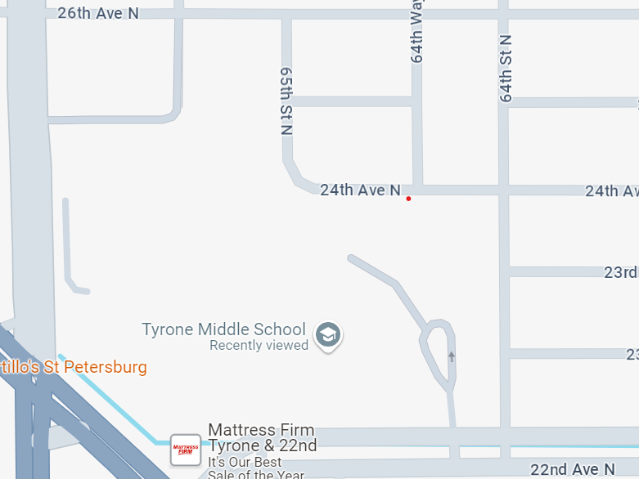

Don’t enter here

Enter here

Park here before bus dismissal